## **Objectives**

* Explain React components
* Identify the differences between components and JavaScript functions
* Identify the types of components
* Explain class component
* Explain function component
* Define component constructor
* Define render() function

In this hands-on lab, you will learn how to:

* Create a function component
* Apply style to components
* Render a component

## **Prerequisites**

The following is required to complete this hands-on lab:

* Node.js
* NPM
* Visual Studio Code

## **Notes**

Estimated time to complete this lab: **30 minutes.**

Create a react app for Student Management Portal named scorecalculatorapp and create a function component named “CalculateScore” which will accept Name, School, Total and goal in order to calculate the average score of a student and display the same.

1. Create a React project named “scorecalculatorapp” type the following command in terminal of Visual studio:



1. Create a new folder under Src folder with the name “Components”. Add a new file named “CalculateScore.js”
2. Type the following code in CalculateScore.js

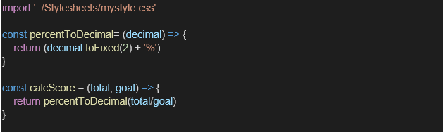

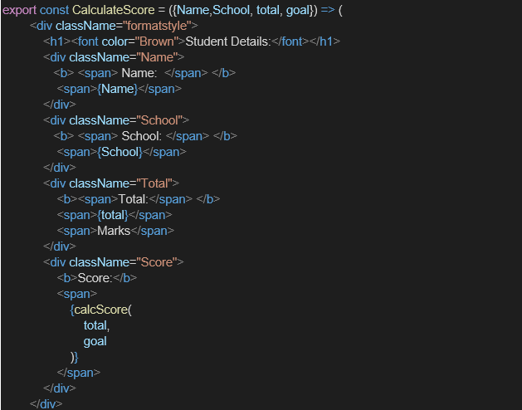

1. Create a Folder named Stylesheets and add a file named “mystyle.css” in order to add some styles to the components:

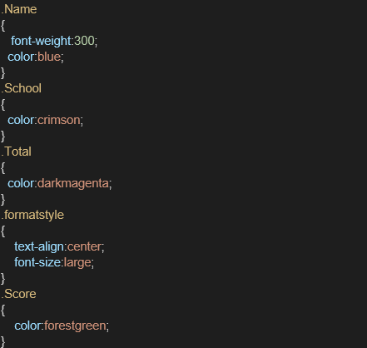

1. Edit the App.js to invoke the CalculateScore functional component as follows:

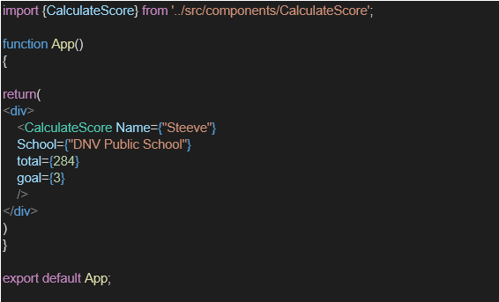

1. In command Prompt, navigate into scorecalculatorapp and execute the code by typing the following command:



1. Open browser and type “localhost:3000” in the address bar:

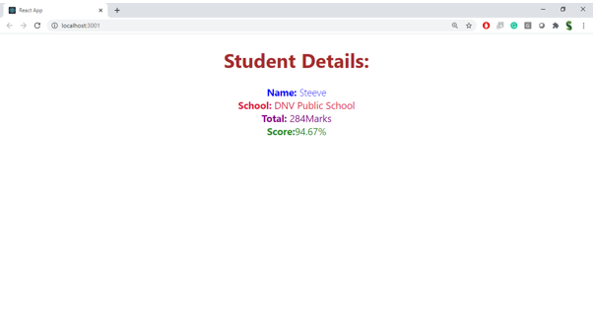

**Program:**

**Index.html:**

<!DOCTYPE html>

<html lang="en">

<head>

<meta charset="utf-8" />

<link rel="icon" href="%PUBLIC_URL%/favicon.ico" />

<meta name="viewport" content="width=device-width, initial-scale=1" />

<meta name="theme-color" content="#000000" />

<meta

name="description"

content="Web site created using create-react-app"

/>

<link rel="apple-touch-icon" href="%PUBLIC_URL%/logo192.png" />

<!--

manifest.json provides metadata used when your web app is installed on a

user's mobile device or desktop. See https://developers.google.com/web/fundamentals/web-app-manifest/

-->

<link rel="manifest" href="%PUBLIC_URL%/manifest.json" />

<!--

Notice the use of %PUBLIC_URL% in the tags above.

It will be replaced with the URL of the `public` folder during the build.

Only files inside the `public` folder can be referenced from the HTML.

Unlike "/favicon.ico" or "favicon.ico", "%PUBLIC_URL%/favicon.ico" will

work correctly both with client-side routing and a non-root public URL.

Learn how to configure a non-root public URL by running `npm run build`.

-->

<title>React App</title>

</head>

<body>

<noscript>You need to enable JavaScript to run this app.</noscript>

<div id="root"></div>

<!--

This HTML file is a template.

If you open it directly in the browser, you will see an empty page.

You can add webfonts, meta tags, or analytics to this file.

The build step will place the bundled scripts into the <body> tag.

To begin the development, run `npm start` or `yarn start`.

To create a production bundle, use `npm run build` or `yarn build`.

-->

</body>

</html>

**Manifest.json:**

{

"short_name": "React App",

"name": "Create React App Sample",

"icons": [

{

"src": "favicon.ico",

"sizes": "64x64 32x32 24x24 16x16",

"type": "image/x-icon"

},

{

"src": "logo192.png",

"type": "image/png",

"sizes": "192x192"

},

{

"src": "logo512.png",

"type": "image/png",

"sizes": "512x512"

}

],

"start_url": ".",

"display": "standalone",

"theme_color": "#000000",

"background_color": "#ffffff"

}

**Robots.txt:**

# https://www.robotstxt.org/robotstxt.html

User-agent: *

Disallow:

**App.css:**

.App {

text-align: center;

}

.App-logo {

height: 40vmin;

pointer-events: none;

}

@media (prefers-reduced-motion: no-preference) {

.App-logo {

animation: App-logo-spin infinite 20s linear;

}

}

.App-header {

background-color: #282c34;

min-height: 100vh;

display: flex;

flex-direction: column;

align-items: center;

justify-content: center;

font-size: calc(10px + 2vmin);

color: white;

}

.App-link {

color: #61dafb;

}

@keyframes App-logo-spin {

from {

transform: rotate(0deg);

}

to {

transform: rotate(360deg);

}

}

**App.js:**

import './App.css';

import { CalculateScore } from './Components/CalculateScore';

function App() {

return (

<div>

<CalculateScore

Name = {"Steeve"}

School = {"DNV Public School"}

total = {284}

goal = {3}

/>

</div>

);

}

export default App;

**App.test.js:**

import { render, screen } from '@testing-library/react';

import App from './App';

test('renders learn react link', () => {

render(<App />);

const linkElement = screen.getByText(/learn react/i);

expect(linkElement).toBeInTheDocument();

});

**Index.css:**

body {

margin: 0;

font-family: -apple-system, BlinkMacSystemFont, 'Segoe UI', 'Roboto', 'Oxygen',

'Ubuntu', 'Cantarell', 'Fira Sans', 'Droid Sans', 'Helvetica Neue',

sans-serif;

-webkit-font-smoothing: antialiased;

-moz-osx-font-smoothing: grayscale;

}

code {

font-family: source-code-pro, Menlo, Monaco, Consolas, 'Courier New',

monospace;

}

**Index.js:**

import React from 'react';

import ReactDOM from 'react-dom/client';

import './index.css';

import App from './App';

import reportWebVitals from './reportWebVitals';

const root = ReactDOM.createRoot(document.getElementById('root'));

root.render(

<React.StrictMode>

<App />

</React.StrictMode>

);

// If you want to start measuring performance in your app, pass a function

// to log results (for example: reportWebVitals(console.log))

// or send to an analytics endpoint. Learn more: https://bit.ly/CRA-vitals

reportWebVitals();

**reportWebVitals.js:**

const reportWebVitals = onPerfEntry => {

if (onPerfEntry && onPerfEntry instanceof Function) {

import('web-vitals').then(({ getCLS, getFID, getFCP, getLCP, getTTFB }) => {

getCLS(onPerfEntry);

getFID(onPerfEntry);

getFCP(onPerfEntry);

getLCP(onPerfEntry);

getTTFB(onPerfEntry);

});

}

};

export default reportWebVitals;

**setupTests.js:**

// jest-dom adds custom jest matchers for asserting on DOM nodes.

// allows you to do things like:

// expect(element).toHaveTextContent(/react/i)

// learn more: https://github.com/testing-library/jest-dom

import '@testing-library/jest-dom';

**package.json:**

{

"name": "scorecalculatorapp",

"version": "0.1.0",

"private": true,

"dependencies": {

"@testing-library/dom": "^10.4.0",

"@testing-library/jest-dom": "^6.6.3",

"@testing-library/react": "^16.3.0",

"@testing-library/user-event": "^13.5.0",

"react": "^19.1.0",

"react-dom": "^19.1.0",

"react-scripts": "5.0.1",

"web-vitals": "^2.1.4"

},

"scripts": {

"start": "react-scripts start",

"build": "react-scripts build",

"test": "react-scripts test",

"eject": "react-scripts eject"

},

"eslintConfig": {

"extends": [

"react-app",

"react-app/jest"

]

},

"browserslist": {

"production": [

">0.2%",

"not dead",

"not op_mini all"

],

"development": [

"last 1 chrome version",

"last 1 firefox version",

"last 1 safari version"

]

}

}

**Output:**

